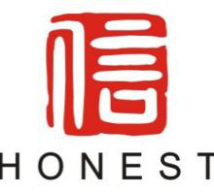

Guangzhou Honest Exhibition Co., Ltd
Shenghui Building, No. 1095, Zhongshan Middle Avenue, Tianhe District, Guangzhou, China

Date: YYYY-MM-DD
CONSULATE GENERAL OF THE PEOPLE’S REPUBLIC OF Country
Regarding: Business visa application for Full Name
To whom it May concern,
This is to confirm that we invite Your Name, Job Title of Company to participate The 10th World Battery & Energy Storage Industry Expo (short for: WBE 2025), an annual event, which will be held during August 8th -10th, 2025 at China Import & Export Fair Complex (Area A), Guangzhou, China. (Set-up period: August 6th-7th and Dismantling period: 2:30PM-5:00PM of August 10th). We would like you to grant him time you want to stay (period) multiple entry business visa.

Your Name details are as follows:
    - Mobile:
    - Date of birth:
    - Passport number:
    - Nationality:
    - Intended dates of participate:
    - Purpose of the participate: To visit WBE 2025
    - Place(s) of participate: Guangzhou, China
    - Relationship: Visitor of WBE

*Please fill in the above information carefully and send it to: WBE@battery-expo.com (Delete after filling)

We request you to kindly grant the visa and oblige. Should you wish to discuss this application further
Please do not hesitate to contact me.

Thank you.
Yours sincerely,
Jenny Chen
Director of Guangzhou Honest Exhibition Co., Ltd

